One source of valence of 2 :

Two patch next to each other that shares 3 vertices, one of 5 and another of 6

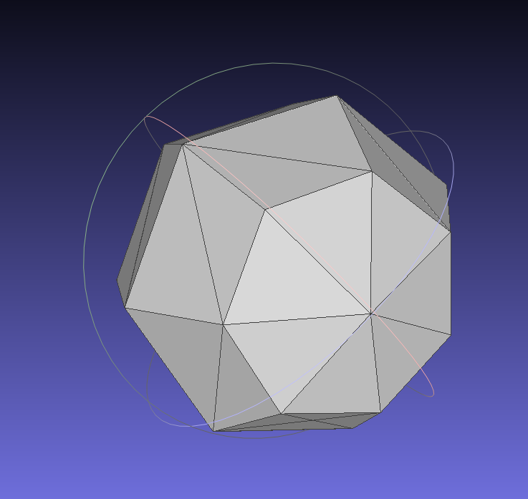

**5**

**6**

When decimating and retriangulate, the result creates a vertex between with a valence of 2

Retriangulation type +

Retriangulation type –

Vertex removed

Gate

Edge border patch

Edge created

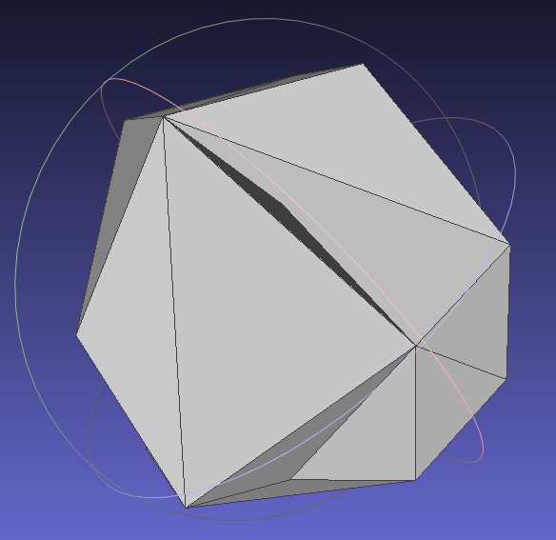

**Valence of 2**

Retriangulation different order (example retriangulation 5 for valence 6 and retriangulation 7 for valence 5)

Potential source: not taking account of already put retriangulation type from previous retriangulation  
X wrong assumption: case with right attribution, but valence of 2

Potential solution: trying a random gate, if decimating obtain valencies of 2, try another gate (like we try to find new gates for the cleaning that don’t have valence of 3).

Potential solution: adapting retriangulation: not recreating an existing face, change the retriangulation to avoid it (existing face invert, normal other direction)

* Need to determine other solution (adapt retriangulation type by inversing + and – of the new ?) => the valence of 2 is a -, need to change it to a 0 to ensure a minimum connection of 4
* /!\ how to manage changement in reconstruction